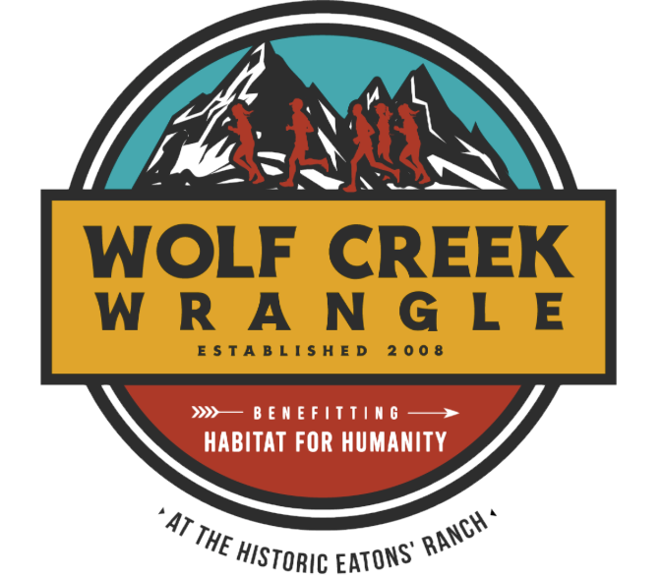**Aid Station Charts**

|  |  |  |  |  |  |
| --- | --- | --- | --- | --- | --- |
| 5 Miles | | | | | |
| Aid station number | Aid Station Name | Miles | Miles to Next AS | Aid | Cutoff |
| 1 | Windy Canyon | 2 | 2 | Water, Tailwind | No |
| 2 | South Red | 4 | .8 | Water, Tailwind, assorted sweet & salty, gels | 2pm |

| 7 Miles | | | | | |
| --- | --- | --- | --- | --- | --- |
| Aid station number | Aid Station Name | Miles | Miles to Next AS | Aid | Cutoff |
| 1 | Windy Canyon | 2 | 2 | Water, Tailwind | No |
| 2 | South Red | 4 | 1.25 | Water, Tailwind, assorted sweet & salty, gels | No |
| 3 | North Red | 5.25 | 1.75 | Water | 2pm |

|  |  |  |  |  |  |
| --- | --- | --- | --- | --- | --- |
| Half Marathon | | | | | |
| Aid station number | Aid Station Name | Miles | Miles to Next AS | Aid | Cutoff |
| 1 | Red Corrals | 1.5 | 3 | Water, Tailwind, assorted sweet & salty, gels | No |
| 2 | Windy Canyon | 4.5 | 2.2 | Water, Tailwind | No |
| 3 | South Red | 6.7 | 1 | Water, Tailwind, assorted sweet & salty, gels | No |
| 4 | North Red | 7.7 | 1.2 | Water | No |
| 5 | Cattle Trails | 8.9 | 2.9 | Water | No |
| 6 | Red Corrals | 11.8 | 1.3 | Water, Tailwind, assorted sweet & salty, gels | 2pm |

|  |  |  |  |  |  |
| --- | --- | --- | --- | --- | --- |
| 18 Miles | | | | | |
| Aid station number | Aid Station Name | Miles | Miles to Next AS | Aid | Cutoff |
| 1 | Red Corrals | 1.5 | 3 | Water, Tailwind, assorted sweet & salty, gels | No |
| 2 | Windy Canyon | 4.5 | 2.2 | Water, Tailwind | No |
| 3 | South Red | 6.7 | 1 | Water, Tailwind, assorted sweet & salty, gels | No |
| 4 | North Red | 7.7 | 1.2 | Water | No |
| 5 | Cattle Trails | 8.9 | 2.9 | Water | No |
| 6 | Red Corrals | 11.8 | 3.2 | Water, Tailwind, assorted sweet & salty, gels | No |
| 7 | Windy Canyon | 15 | 3 | Water, Tailwind | No |
| 8 | South Red | 17.2 | .6 | Water, Tailwind, assorted sweet & salty, gels | 2pm |